# 

# Fiazaan Arshad

# SP18-MCS-013

# Software Engineering - II (SE-II)

# Assignment # 2

# April 26, 2019

# GitHub Repository

## Add Files to Repository using GitBash Commands:

### Step – I:

In this step, by using some of the commands which are given below for getting access of my GitHub account through Get Bash. Some of the commands are listed below:

1. cd (**cd** command for changing directories).

2. ls (**ls** for showing list).

3. git init (The **git init** command creates a new **Git** repository).

4. git remote (A **remote** in **Git** is a common repository that all team members use to exchange their changes).

5. git add (**Add** files to the staging area by using the "**git add**" command).

6. git commit (The "**commit**" command is used to save your changes to the local repository).

7. git push remote (**git push origin master** will **push** changes from the local **master** branch to the remote **master** branch).

8. git remote set-url (The **git remote set**-**url** command changes an existing **remote** repository **URL**

## Step-I:

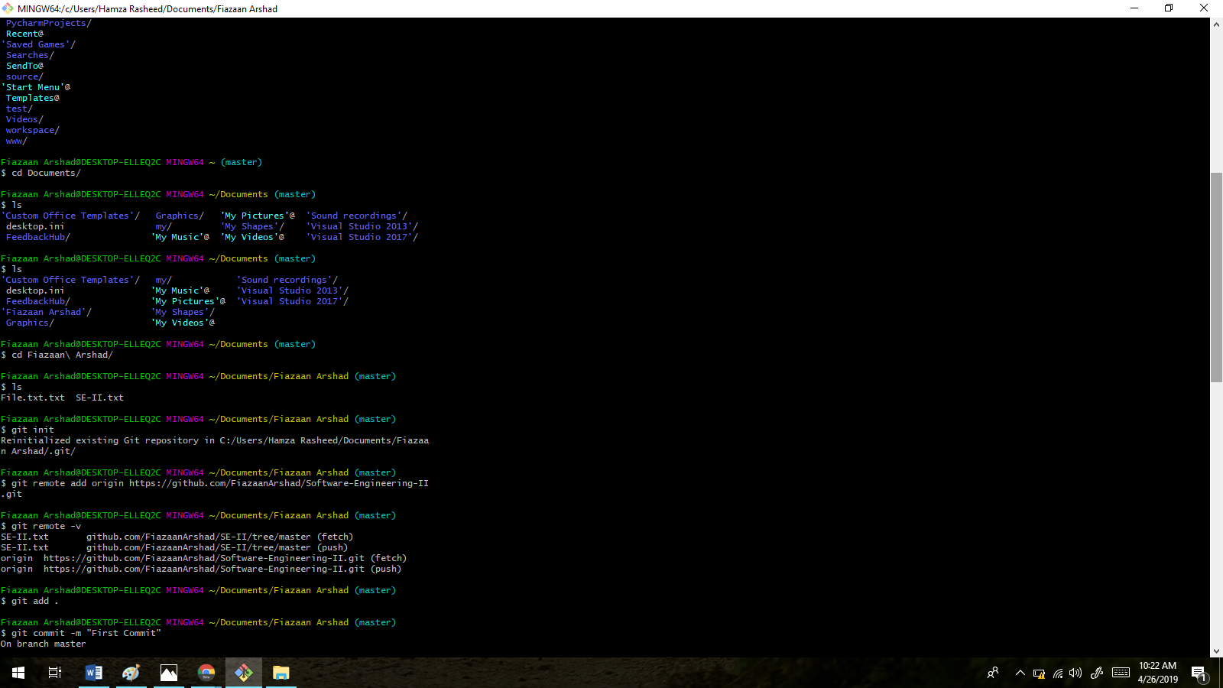

### Step – II:

In this step, sending invitation to one of selected contributor through which using his/her GitBash console commands to send or upload commands to our repository.

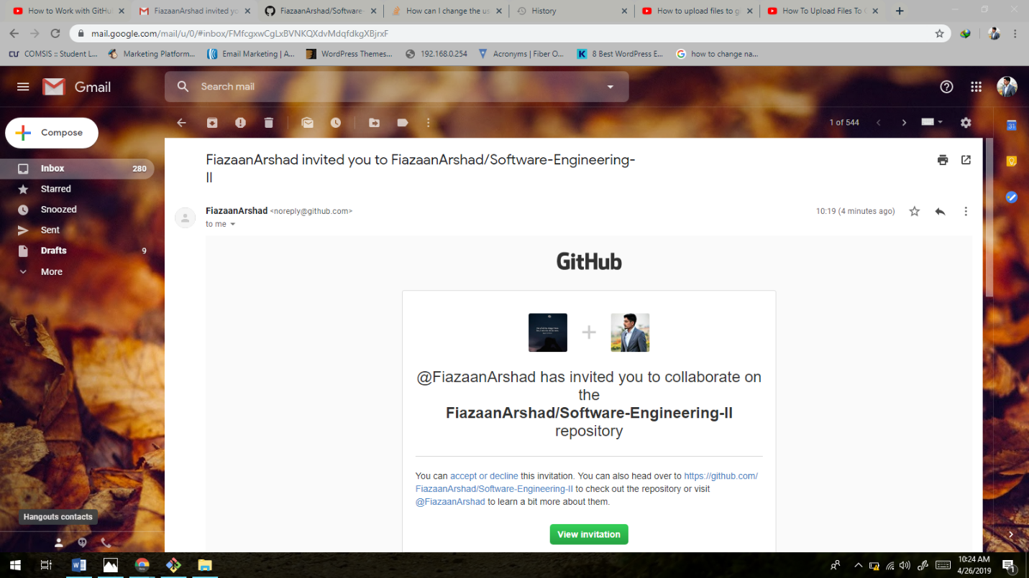

### Step –III:

As we can see that, now he/she can take part in our repository. Contributor can participate to edit and maintain our repository.

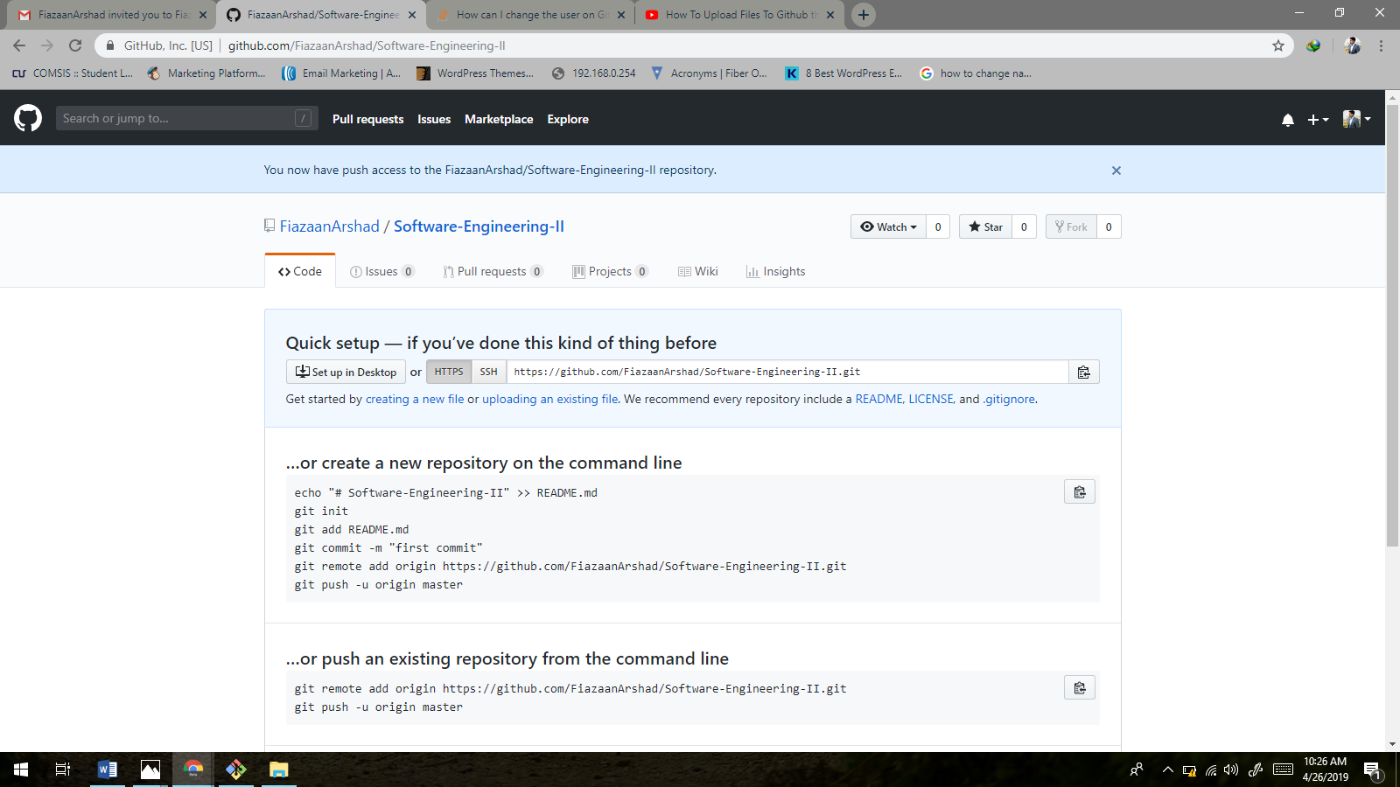

### Step –IV:

Files are being uploaded in owner/master repository by contributor GitBash console respectively.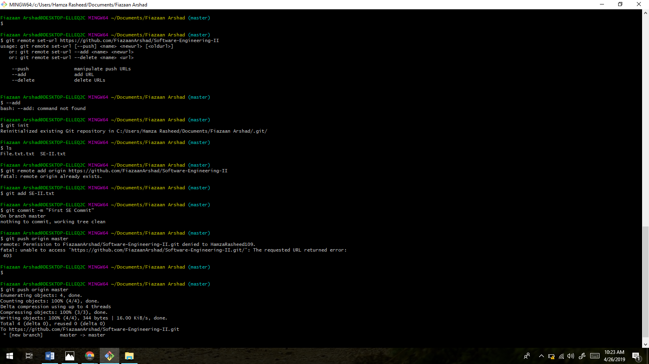

### Step –V:

This step confirms contributor as part of repository.

